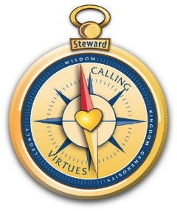
THE NATIONAL CENTER FOR
STEWARDSHIP
& GENEROSITY

2015 Lifetime Stewardship Achievement Award Honoree
Sylvia A Crecelius, CLSA™
Princeton, IN

In 2015, the Board of Regents felt it important to nominate one of their own for the first, inaugural, class of recipients recognized for Lifetime Stewardship Achievement. That member leader was and is, Sylvia Crecelius, one of the core founders of The National Center for Stewardship & Generosity.
Sylvia has spent a lifetime in the financial services industry as well as the Christian ministry sphere. In both realms, business and ministry simultaneously, she has been a leader: planning for, protecting, and advancing not only her business clients, but also protecting and advancing ministries and their leaders. She has been one of the longest serving proponents and advocates for the centrality of whole life biblical stewardship principles in both financial business practices as well as at the forefront of Christian ministries and their leaders. Those who know her well would quickly state that it would be difficult to identify a major stewardship endeavor in the United States, especially since she was widowed, in which Sylvia did not play a role and work to advance.
Professionally, Sylvia and her late husband, Bob, were active in the creation of the Certified Financial Planner® designation in the late 1960s and early 1970s. Not only were they early recipients of that designation but they continued their contribution to the field during the early years of financial planning, working on course and examination development. In the field of nonprofit and for profit financial services, Sylvia was one of the few women to have earned the CPF® designation. In practice since 1970, she has served many clients, their families (multi-generationally) and their businesses for a period of 40 years or more.
Sylvia’s leadership of the national membership of The Stewardship Alliance, established 2001, was evidence of her collaborative style, positive sense of humor, and willingness to help on any team.
The core operating principle in Sylvia’s personal and professional effort is unusual yet effective, with demonstrated results. Simply stated, she seeks to be “never a king, but always a kingmaker”. She dedicates her effort to areas of responsibility that will help others achieve their potential. Those who have labored with her in the field of stewardship have experienced the value of that attitude and effort.
Stewardship has not traditionally been a women’s field in the last hundred years. There can be found less than 20 women leaders, authors, or entrepreneurs in the stewardship field during the past 30 years. Sylvia stands as one of the longest serving American women leaders of stewardship organizations and stewardship ministry efforts.

